

# Software Engineering Foundations, F21SF Heriot Watt University

# Assignment 2

# Written by Kamontorn Khamrun (H00144659), Marcin Kopacz (H00176255) and Stian Dalviken (H00024901)

Table of Contents

1. Status report 3

2. Use Case Diagram and Activity Diagram 3

Registration detail description 3

Registration activity diagram 4

Check the Correctness 5

3. Class Diagram 6

4. Input and output text files 7

Bowler 7

Golfer 7

Soapbox 8

Output file 8

5. GUI features 9

6. Assumptions and limitations 13

Assumptions 13

Limitations 13

7. Error table 13

# 1. Status report

Our application fully meets all specifications specified in this assignment.

# 2. Use Case Diagram and Activity Diagram



## Registration detail description

Use case: Registration  
Goal: To registration competitors  
Actors: Competitor, system

**Main success scenario**

1. Competitor goes to online registration webpage.
2. Competitor fills the registration form which include name, e-mail, date of birth, category, and level.
3. System checks the correctness.
4. Registration accepted.
5. System allocates a unique competitor number.

**Alternative**

4a. Competitor omits any field

1. Competitor is asked to re-submit the form.
2. Continue from 2.

4b. Competitor age is not compatible with level.

1. Competitor is asked to change level.
2. Continue from 2.

4c. Competitor e-mail and category are already existent in the recorded system.

1. Registration refuses.

## Registration activity diagram

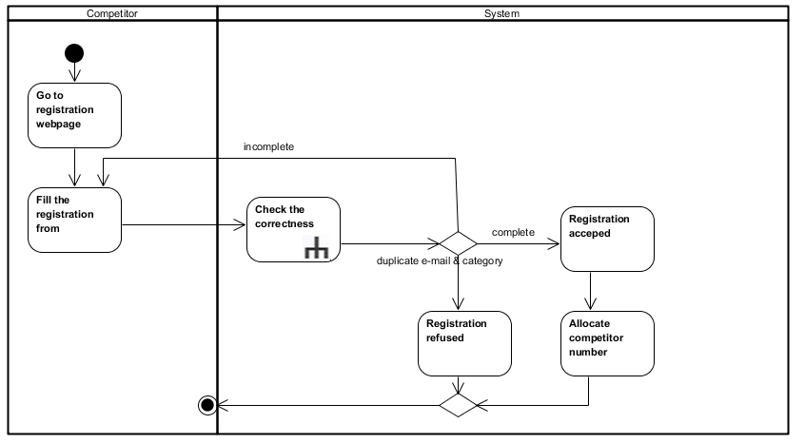

## Check the Correctness

**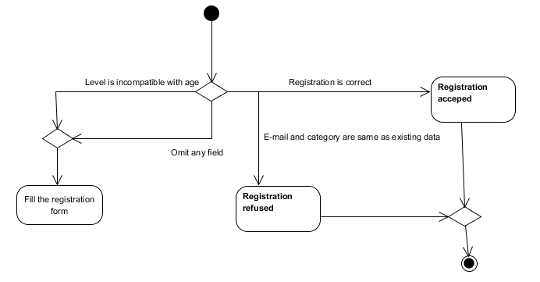**

# 3. Class Diagram

Below is the class diagram of the Java application, which gives an overview of all the classes in the application, as well as showing the links between them.

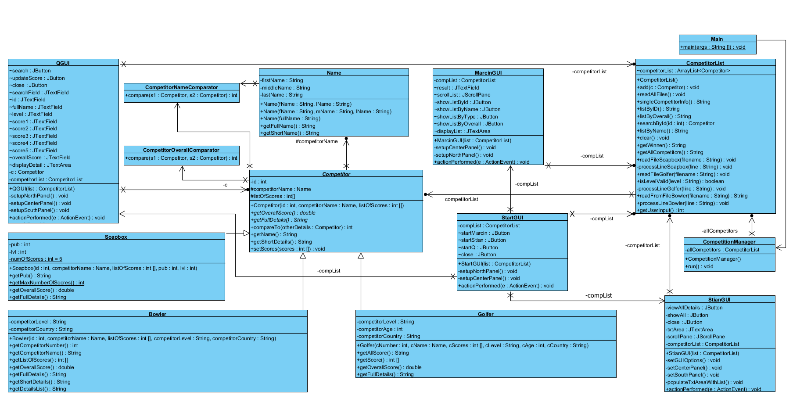

# 4. Input and output text files

The following shows screenshots of the input files and the output file.

## Bowler

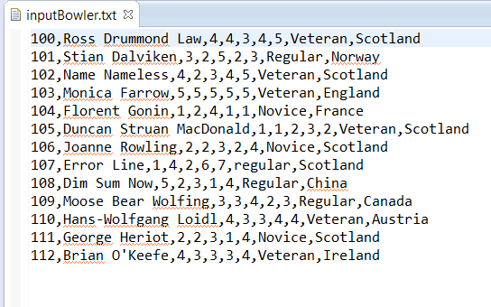

## Golfer Macintosh HD:Users:Stian:Downloads:Sample for 5:inputGolfer.PNG

## Soapbox Macintosh HD:Users:Stian:Downloads:Sample for 5:inputSoapbox.PNG

## Output file

## Macintosh HD:Users:Stian:Downloads:Sample for 5:OutputData.PNG

# 5. GUI features

## StartGUI

## Macintosh HD:Users:Stian:Downloads:Start GUI.png

## MarcinGUI ("Sorting by Marcin")

## Macintosh HD:private:var:folders:0b:yy3y_xr94vz61yyjt1rd3z8m0000gn:T:com.skitch.skitch:Marcin_GUI_functions.png.jpg

## StianGUI (Search by Stian)

1. The user is presented with a list of all the competitors from all three competitions. The user can see full and short details of a specific competitor by clicking on the "View details of competitor" button in the window

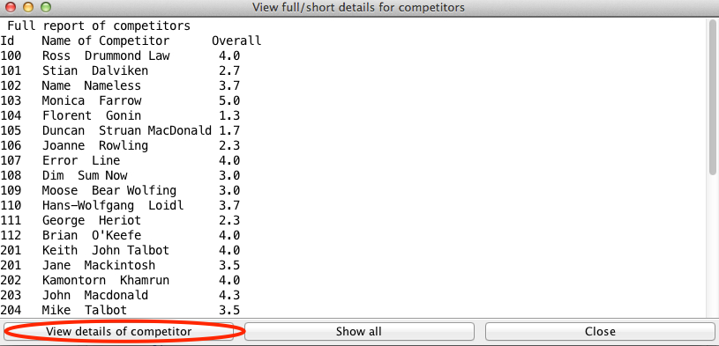

2. When the user clicks the button in the red circle in the screenshot above, the user will get presented with the below input window where the user can write the competitor number/ID of the competitor the user would like full and short details for

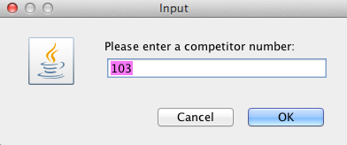

3. When the user has entered a competitor number/ID and clicked ok, the user will be presented with the full and short details for the competitor with the inputted competitor number/ID, shown in the screenshot below.  
The user can easily get back to the full competitor list by clicking on the "Show all" button, which is showed in the red circle in the screenshot below

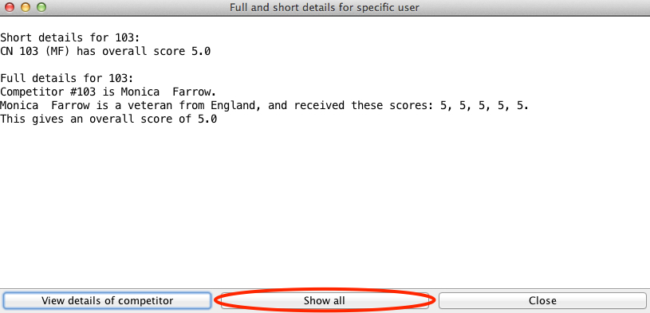

## KamontornGUI (Modification by Q)

1. User can search score, full name, score, and overall score by Competitor ID

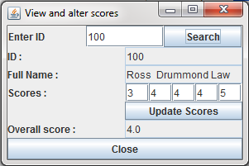

1. The program shows ID, full name, score and overall score



1. User can update competitor scores

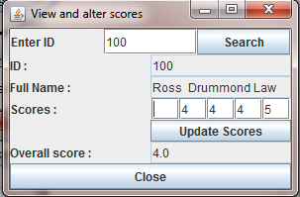

1. After update the program is re-calculated the overall score and shows instead old overall score

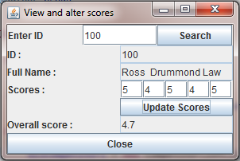

1. GUI can be closed separately from the program.



# 6. Assumptions and limitations

## Assumptions

* Files only have correct data about competitors
* Competitor ID's are unique

## Limitations

* Files must be in correct format and location, if not, the program will show error messages
* User cannot make any modification in the report file: OutputData
* If an ID is a duplicate, then features for search and modification will not work properly

# 7. Error table

|  |  |
| --- | --- |
| Incorrect data of competitors in input files | Error message will be displayed and program will skip the line |
| Wrong name or missing input or output file | Error message will be displayed |
| Searching for competitor to get full/short details, if cancel is pressed during selection | Error message will be displayed |
| When user search for nonexistent competitor ID to modify scores | Error message will be displayed |
| When user update a scores using wrong values (i.e. lower than 0 and higher than 5, or letters) | Error message will be displayed |
| When entering a letter in the search box to alter a score for a competitor | Error message will be displayed |